Children’s Mental Health Entry User Guide

This user guide describes how to use eQHealth Solutions (eQHealth) web based data entry screen for recording children’s mental health admissions. Users of the system include the CARES contractor, SASS contractors as well as Healthcare and Family Services (HFS).
What Is Needed To Use the System?
- Internet access
- A computer with the following minimum specifications:
- Pentium 133 with 16mg RAM and 5mg free disk space for drivers
- Color monitor
- 28.8K modem connection or higher; high-speed Internet access is preferable
- Internet Explorer Version 5.5 or higher with 128-bit encryption.

Accessing the System

eQHealth will assign a logon and password a hospital-designated “User Administrator”, who will then grant access for each user who needs to access the system by creating user passwords.

eQHealth’s Web based entry system is accessed from our Web site home page.
- Access the Internet with Internet Explorer and go to il.eqhs.org
- Click on the side bar Links to eQHealth Web Systems: “CMH Entry”

The user must login to access the CMH data entry system. Enter your assigned User Id and Password here. The password must be entered for confidentiality, security and tracking purposes. IMPORTANT NOTE: Each user is responsible for maintaining the confidentiality of their individual logon. If you believe your password has been compromised, immediately notify your Web Administrator to reset your password.

The following screen allows the user to “Add New Entry” or to “List Existing Entries”. Existing entries can be viewed or certain fields can be updated.

Record access and editing is controlled by the user type. There are three user types allowed in the system: CARES, SASS and HFS.

1. CARES users can access/view all records because their entry is possible on all records.
2. HFS users can access/view all records because their entry is possible on all records.
3. SASS users are limited in record access/view as follows:
If a record added by CARES does not have SASS entry information on it, then it can only be accessed by SASS by the user keying in the RIN or the Entry Number (entry number is an internal eQHealth record identification number).

If a SASS user keys in a RIN or an Entry Number, then edits are performed and only the following records are displayed:
- Records with no SASS information.
- Records where this SASS entered the “first date of involvement field” (First SASS Editor).
- Records where this SASS entered the “involved in discharge planning field” (Last SASS Editor).

Record access/view for the following options only displays data where this SASS provider number is currently on file as the First SASS Editor or the Last SASS Editor.

Records with no SASS information and records without this SASS provider number are NOT displayed or accessible.
  - Hospital number [must also have a date range entered]
  - Admit date range
  - Added to file date range
  - Only those added by CARES [must also have a date range entered]
  - Discharge Planning = N [only displayed for SASS users]

Add New Entry

Example of an initial entry screen. Depending on the type of provider logged on (CARES, SASS or HFS) the appropriate entry section will be highlighted and the non-updateable fields will be grayed and protected.
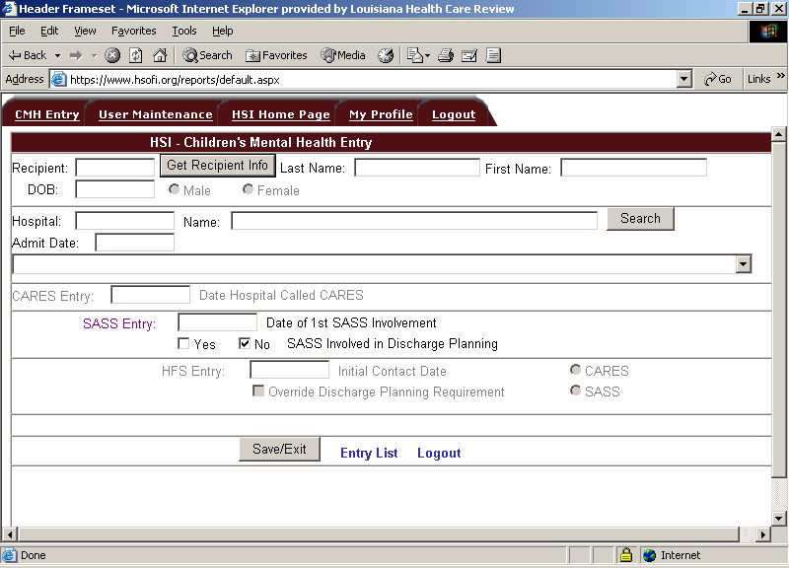

Keying in the 12 digit hospital number and hitting the “SEARCH” button will retrieve the hospital, or keying in any part of the hospital name and hitting the “SEARCH” button and clicking the drop-down caret will list all hospitals on file with that name fragment. The screen below shows Chicago as the search word. The city and state are also listed to aid in identification of the correct facility. Click the appropriate facility and the system will copy the provider number and name into the data entry fields.
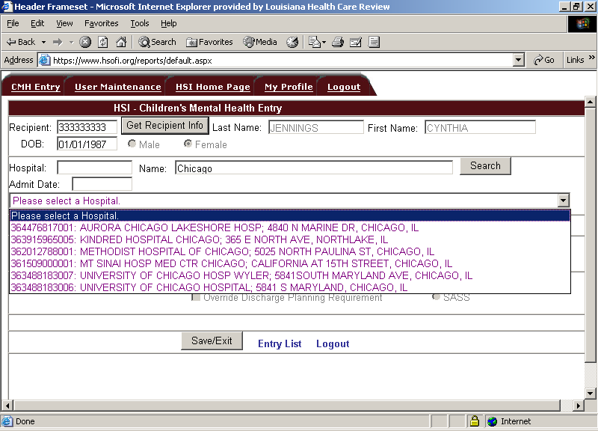

Example of an existing record retrieved for viewing or input. Added to file and last edit
data by user type are also displayed at the bottom of the screen.

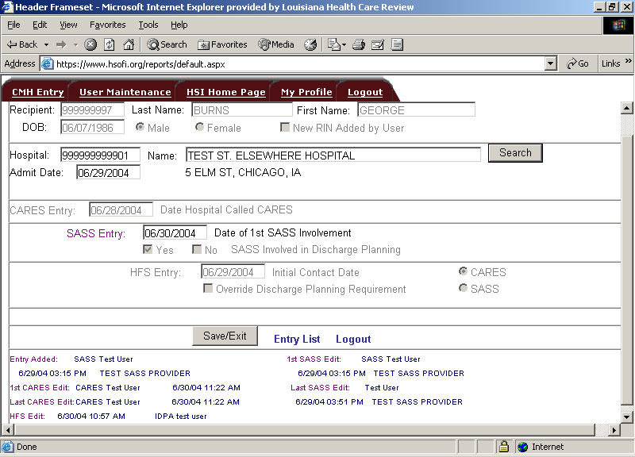

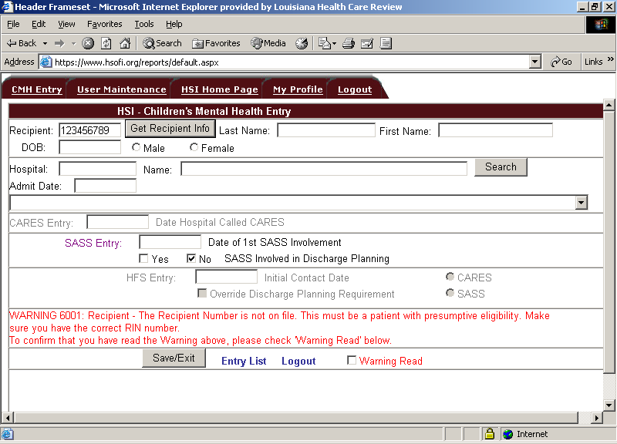
Example of a warning or error message. If a data entry error is made or there is a warning
message, the
system will display the message(s) at the bottom of the screen. The user must click the “Warning Read” box before the system will allow you to continue. This acknowledges that you have read the message.

Data Entry Field Descriptions:

Field Name | Description
Recipient Information | When a record is created, a valid Medicaid recipient number (RIN) must be entered. If the recipient number entered is on HSI’s data file then the corresponding last name, first name, date of birth (DOB) and gender will be displayed on the screen when the user hits the “Get Recipient Info” button.  If the RIN is not on eQHealth’s data file then the user will receive a warning message stating that this must be a patient with presumptive eligibility and that the CARES contractor has recently created a RIN for the patient. If this is acknowledged by the user, then the user must enter the corresponding last name, first name, date of birth and gender.  The system will restrict entry to patients under 21.  If the RIN was not on eQHealth’s data file and was added by the user then the “New RIN Added by User” flag will be checked by the system.
Hospital Information | When a record is created, a valid Medicaid provider number must be entered. It is imperative that the correct hospital be identified else the eQHealth medical necessity review cannot occur.  Keying in the 12 digit hospital number and hitting the “SEARCH” button will retrieve the hospital, or keying in any part of the hospital name and hitting the “SEARCH” button and clicking the drop-down caret will list all hospitals on file with that name fragment. The city and state are also listed to aid in identification of the correct facility. Click the appropriate facility and the system will copy the provider number and name into the data entry fields.
Admit Date | If the user adding or editing the record is a SASS or HFS user then an admit date must be entered. This is the date the patient was admitted to the hospital. If an actual admission did not occur then SASS does not need to update this record because no eQHealth medical necessity review will be requested by the hospital.  Only record actual admit dates. The system will not allow ‘future’ dates to be entered.

CARES ENTRY
Date Hospital Called CARES | Only CARES users may enter into this field. The CARES user must enter the date the hospital first called CARES regarding the potential or actual admission.  All hospital days incurred prior to the earliest of either  the CARES contacted by hospital date  the SASS 1st involvement date  the HFS recorded initial contact date  will be deemed non-covered for hospital payment purposes.

SASS ENTRY
Date of 1st SASS Involvement | Only SASS users may enter into this field. Record the first date of SASS involvement for this admission.  All hospital days incurred prior to the earliest of either  the CARES contacted by hospital date  the SASS 1st involvement date  the HFS recorded initial contact date  will be deemed non-covered for hospital payment purposes.
SASS Involved in Discharge Planning | Only SASS users may enter into this field. This field captures that SASS was involved in discharge planning for each CMH hospitalization.  The system will default to the answer of “N”. If SASS is involved in discharge planning, then the SASS user will go to this entry screen and change the “N” to “Y”. NOTE: Once the value is set to “Y”, it is locked.

HFS ENTRY
Initial Contact Date | Only HFS users may enter into this field. Record the first contact date of SASS or CARES.  All hospital days incurred prior to the earliest of either  the CARES contacted by hospital date  the SASS 1st involvement date  the HFS recorded initial contact date  will be deemed non-covered for hospital payment purposes.
EDIT DATES | These are system populated fields for tracking purposes. They are displayed on the screen for informational purposes only. The user name, edit date and time and corresponding provider name is tracked and displayed for the following events:  Entry Added 1st SASS Edit  CARES Edit Last SASS Edit  HFS Edit  Note the actual SASS or CARES provider number is also on file.

Save/Exit
When entry for a given record is complete, click the Save/Exit button at the bottom of the entry screen. All data edits will be checked at this time. If the record passes all edit checks, the information will be added to eQHealth’s data table. The user will be given a verification message by the system which will display the unique eQHealth Entry number assigned to the record.

If any edit errors are detected, the system will display the error message on the screen, and the user can add/change data as needed.

Once a data field is entered and saved it cannot be changed. The only exception is that the SASS user can change the “involvement in discharge planning” field from “N” to “Y” at any time.

User Maintenance

Each contractor will have one person designated to be the user access or User Administrator. They will be allowed to add new users, change passwords and deactivate users who should no longer have access to the system.

For security compliance, each user is responsible for keeping their logon secure. If a user feels that their logon has become compromised, they must notify the administrator who should access the maintenance option and change the user’s password.

If for any reason the facility access administrator is no longer with the contractor or will no longer serve in this position, HSI should be contacted and the master files will be updated to grant administrator rights to another designated individual.

The User Maintenance module is accessed via User Maintenance link on the top of the page

Adding/Modifying User Logon Information
When the administrator clicks the User Maintenance tab, an “Administration of Authorized Users” screen (shown below) will be displayed. This screen displays a list of all users currently on file for this contractor/provider number. The administrator can add a new user or edit logon information for an existing user.
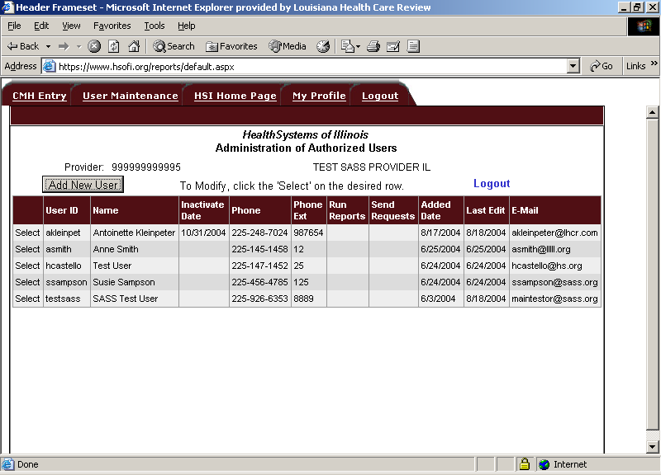

- Click the “Add New User” button to enter logon information for a new user.

- To modify information on an existing user, click the word Select next to the ID of the appropriate user.

This screen captures logon information for each user.
To save the logon information, click the Save/Exit button.

NOTE: All required data fields must be entered before the system will save the information.

If the system does not detect any errors, the user will be given a message verifying that the user logon information was successfully saved to HSI’s web logon data table.

User Maintenance  Field Name | Description
User ID | Unique user identifier. Must be between 6 and 10 characters. All alpha characters must be in lowercase. Example: user’s first initial then last name.  The Logon ID must be unique across all users of HSI Web based systems. If you enter a Logon ID and the system responds that this ID is already on file, then you must use a different ID. A common solution to this situation is to append a numeric digit at the end of the last name. For example, user “Jane Doe” would be jdoe1.
Password | Must be between 6 and 10 characters. All alpha characters must be in lowercase. Each user is responsible for keeping this password confidential.
Name | The user’s name.
Phone and  Phone Extension | Record the user’s phone number and phone extension.
Inactivate Date | Once users are added by the contractor access administrator they cannot be deleted. This is for tracking and audit trail purposes.  If a user is no longer with the contractor or is no longer authorized to access the confidential data, then the facility access administrator should immediately inactivate their logon. Simply key a date into this field and save, and the user logon will be inactivated from the entered date forward.
E-Mail | Enter the user’s e-mail address.

